1. Before we start to publish and consume the message using Apache ActiveMQ, we need to set the authentication & Authorization.  
   We have used the default username (admin) and password (admin) to access the **Web Console** of Apache ActiveMQ.
2. **NOTE**: Please note that Web Console and Broker Server, both are different. So, their credentials are different.
3. But to publish and consume messages in queue/topic from Our Java App (Publisher or Consumer), we need to use URL of Message Broker (simply **Broker URL**) using the **TCP protocol**.
4. Okay, but Broker configuration comes without any **pre-defined authentication and authorization**.   
   So, anyone who has Broker URL can publish or consume messages from ActiveMQ.  
   But going without authentication & authorization is not a good way.
5. The credentials username=admin, password=admin, we used was for **ActiveMQ console**.
6. So, we have two kinds of credentials.
   1. One for ActiveMQ Console.
   2. Other for Publishing and Consuming messages from a queue/topic.
7. 
8. See, this activemq.xml file is a spring bean file so it has <beans> tag.   
   In the below slides, we have two plugins one for authentication and other for authorization.  
   Put the **<plugins>** under **<broker>** at the end.
9. 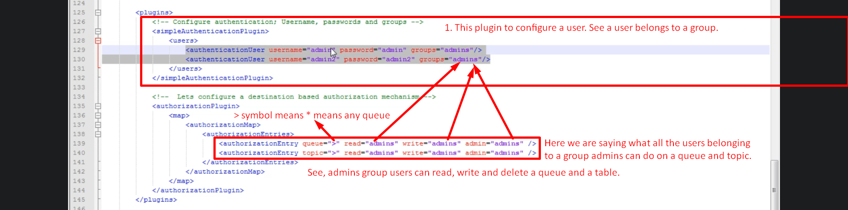
10. So, we have configured one Broker user which can publish and consume message from an ActiveMQ Broker’s queue and topic.